**TASK 1:**

**Train the decision tree using the dataset provided in the lab also given below.**

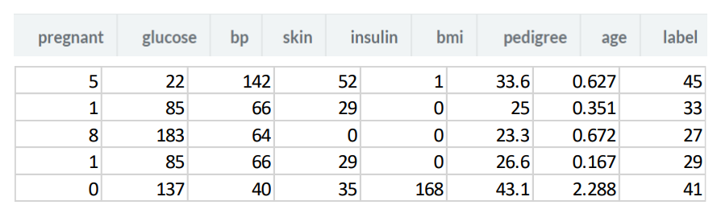

**CODE:**

# Owned  
__author__ = "Qaiser Abbas"  
__copyright__ = "Copyright 2020, Artificial Intelligence lab-13"  
__email__ = "qaiserabbas889@yahoo.com"  
#===============================================================  
# {code}  
import os  
import pandas as pd  
from sklearn.tree import DecisionTreeClassifier  
from sklearn.model_selection import train_test_split  
from sklearn import metrics  
from sklearn.tree import export_graphviz  
from six import StringIO  
from IPython.display import Image  
import pydotplus  
col_names = ['patient', 'glucose', 'bp', 'skin', 'insulin', 'bmi', 'pedigree', 'age', 'label']  
pima = pd.read_csv("test.csv", header=None, names=col_names)  
pima.head()  
feature_cols = ['patient', 'insulin', 'bmi', 'age','glucose','bp','pedigree']  
X = pima[feature_cols]  
y = pima.label  
X_train, X_test, y_train, y_test = train_test_split(X, y, test_size=0.3, random_state=1) # 70% training and 30% test  
clf = DecisionTreeClassifier()  
clf = clf.fit(X_train,y_train)  
y_pred = clf.predict(X_test)  
print(y_pred)  
dot_data = StringIO()  
export_graphviz(clf, out_file=dot_data,  
 filled=True, rounded=True,  
 special_characters=True,feature_names = feature_cols,class_names=['0','1'])  
graph = pydotplus.graph_from_dot_data(dot_data.getvalue())  
  
graph.write_png('qaiser.png')  
Image(graph.create_png())

**OUTPUT:**

